WEB TECHNOLOGY ASSIGNMENT 2
Done By
IMCA-592 ABHIMANYU T S
IMCA-593 ARDRA P RAJ

Study Leave Timetable for IMCA Semester 5

Introduction
During study leave, students may find it difficult to plan their studies and remember which subject to study each day. To solve this problem, I developed a simple website called Study Leave Timetable for IMCA Semester 5.

Problem Identified
Students may face difficulties in managing their study time and completing all subjects before the examination. They need a simple way to organize their daily study plans.

Proposed Solution
I created a website that displays the study leave timetable for October and November 2026. Important study dates are highlighted in light purple. When a student clicks on a date, the corresponding study plan is displayed below the calendar.

Technologies Used
- HTML – To create the structure of the website.
- CSS – To design the webpage, calendar, colours and layout.
- JavaScript – To generate the calendars, highlight dates and display the study plan when a date is selected.

Output
The website displays two monthly calendars along with a Study Plan section. Initially, a message asks the user to click on a date. When a date is selected, the corresponding date and subject are displayed. For example, selecting 3 November 2026 displays Web Technology.

Conclusion
This website helps students organize their study schedule in a simple and clear way. It helps them plan their study time, keep track of subjects and prepare for examinations more effectively.
CODE:
<!DOCTYPE html>
<html>
<head>
<title>Study Leave Timetable of IMCA SEM 5</title>
<style>
body {
font-family: Arial, sans-serif;
background-color: #f4f6fa;
margin: 0;
padding: 20px;
text-align: center;
}
h1 {
color: #111166;
font-size: 36px;
margin-bottom: 35px;
}
#calendars {
display: flex;
gap: 25px;
justify-content: center;
}
.month {
background-color: white;
border: 1px solid #b8c9e0;
border-radius: 5px;
width: 50%;
overflow: hidden;
}
.month h2 {
background-color: #e9efff;
color: #111166;
padding: 18px;
margin: 0;
font-size: 27px;
}
.calendar {
display: grid;
grid-template-columns: repeat(7, 1fr);
gap: 1px;
background-color: #e0e4ed;
}
.calendar div {
padding: 18px 2px;
background-color: white;
font-size: 18px;
}
.weekday {
background-color: #eef1f7 !important;
font-weight: bold;
}
.date {
cursor: pointer;
}
.study-leave {
background-color: #e4e1ff !important;
}
.date:hover {
background-color: #d0caff !important;
}
.selected {
background-color: #8260d0 !important;
color: white;
}
#studyPlan {
background-color: white;
border: 1px solid #b8c9e0;
border-radius: 5px;
margin-top: 22px;
min-height: 210px;
overflow: hidden;
}
#studyPlan h2 {
background-color: #e9efff;
color: #111166;
padding: 18px;
margin: 0;
font-size: 28px;
}
#planDate {
color: #111166;
font-size: 28px;
margin-top: 30px;
}
#planText {
font-size: 22px;
margin-bottom: 35px;
}
@media (max-width: 700px) {
h1 {
font-size: 25px;
}

#calendars {
flex-direction: column;
}
.month {
width: 100%;
}
}
</style>
</head>
<body>
<h1>Study Leave Timetable of IMCA SEM 5</h1>
<div id="calendars"></div>
<div id="studyPlan">
<h2>Study Plan</h2>
<h2 id="planDate" style="display:none;"></h2>
<p id="planText">
Click on a date to view the study plan.
</p>
</div>
<script>
var plans = {
"2026-10-23": "Python Record Writing",
"2026-10-24": "Python Record Writing",
"2026-10-25": "Python Record Completion",
"2026-10-26": "Web Record Softcopy Setup",
"2026-10-27": "Web Record Softcopy Setup",
"2026-10-28": "Web Record Completion and Checking",
"2026-10-29": "Software Engineering and Project Management",
"2026-10-30": "Software Engineering and Project Management",
"2026-10-31": "Object Oriented Modelling and Design",
"2026-11-01": "Object Oriented Modelling and Design",
"2026-11-02": "Web Technology",
"2026-11-03": "Web Technology",
"2026-11-04": "Operating System",
"2026-11-05": "Operating System",
"2026-11-06": "Operations Research",
"2026-11-07": "Operations Research",
"2026-11-08": "Software Engineering + OOMD Revision",
"2026-11-09": "Web Technology + OS Revision",
"2026-11-10": "Operations Research Problems + Revision"
};
var calendars = document.getElementById("calendars");
function createCalendar(month, year) {
var monthNames = [
"January", "February", "March",
"April", "May", "June",
"July", "August", "September",
"October", "November", "December"
];
var weekdays = [
"Sun", "Mon", "Tue", "Wed",
"Thu", "Fri", "Sat"
];
var firstDay = new Date(year, month, 1).getDay();
var totalDays = new Date(year, month + 1, 0).getDate();
var html = "<div class='month'>";
html += "<h2>" + monthNames[month] + " " + year + "</h2>";
html += "<div class='calendar'>";
for (var i = 0; i < 7; i++) {
html += "<div class='weekday'>" + weekdays[i] + "</div>";
}
for (var i = 0; i < firstDay; i++) {
html += "<div></div>";
}
for (var day = 1; day <= totalDays; day++) {
var monthNumber = month + 1;
var dayNumber = day;
if (monthNumber < 10) {
monthNumber = "0" + monthNumber;
}
if (dayNumber < 10) {
dayNumber = "0" + dayNumber;
}
var dateKey = year + "-" + monthNumber + "-" + dayNumber;
var className = "date";
if (dateKey >= "2026-10-23" &&
dateKey <= "2026-11-10") {
className += " study-leave";
}
html += "<div class='" + className +
"' onclick=\"showPlan('" + dateKey +
"', this)\">" + day + "</div>";
}
html += "</div></div>";
calendars.innerHTML += html;
}
function showPlan(date, element) {
var plan = plans[date];
var parts = date.split("-");
var year = parts[0];
var month = parseInt(parts[1]);
var day = parseInt(parts[2]);
var monthNames = [
"January", "February", "March",
"April", "May", "June",
"July", "August", "September",
"October", "November", "December"
];
var formattedDate = day + " " +
monthNames[month - 1] + " " + year;
var dates = document.querySelectorAll(".date");
for (var i = 0; i < dates.length; i++) {
dates[i].classList.remove("selected");
}
element.classList.add("selected");
document.getElementById("planDate").style.display = "block";
document.getElementById("planDate").innerText =
formattedDate;
if (plan) {
document.getElementById("planText").innerText = plan;
} else {
document.getElementById("planText").innerText =
"No study plan for this date.";
}
}
createCalendar(9, 2026);
createCalendar(10, 2026);
</script>
</body>
</html>

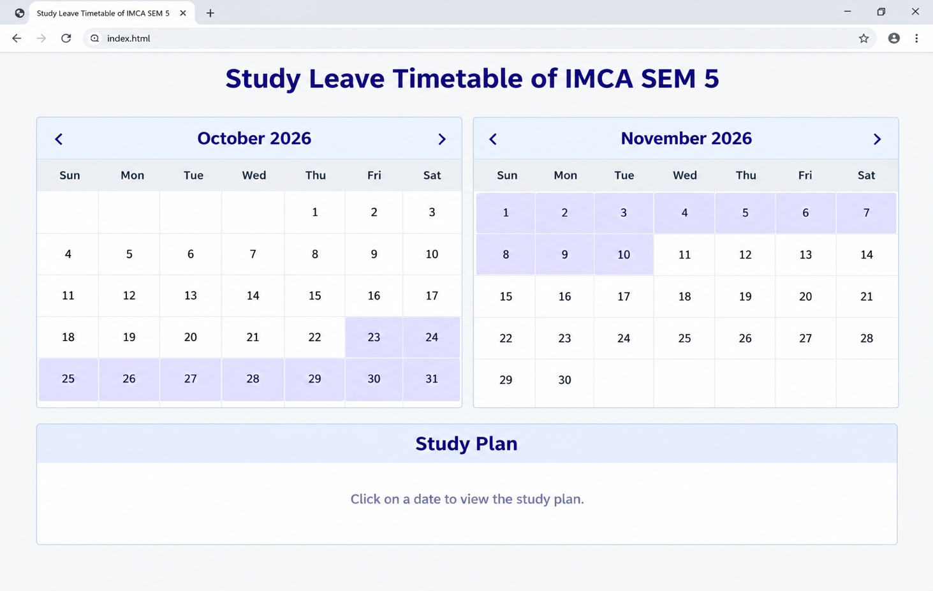
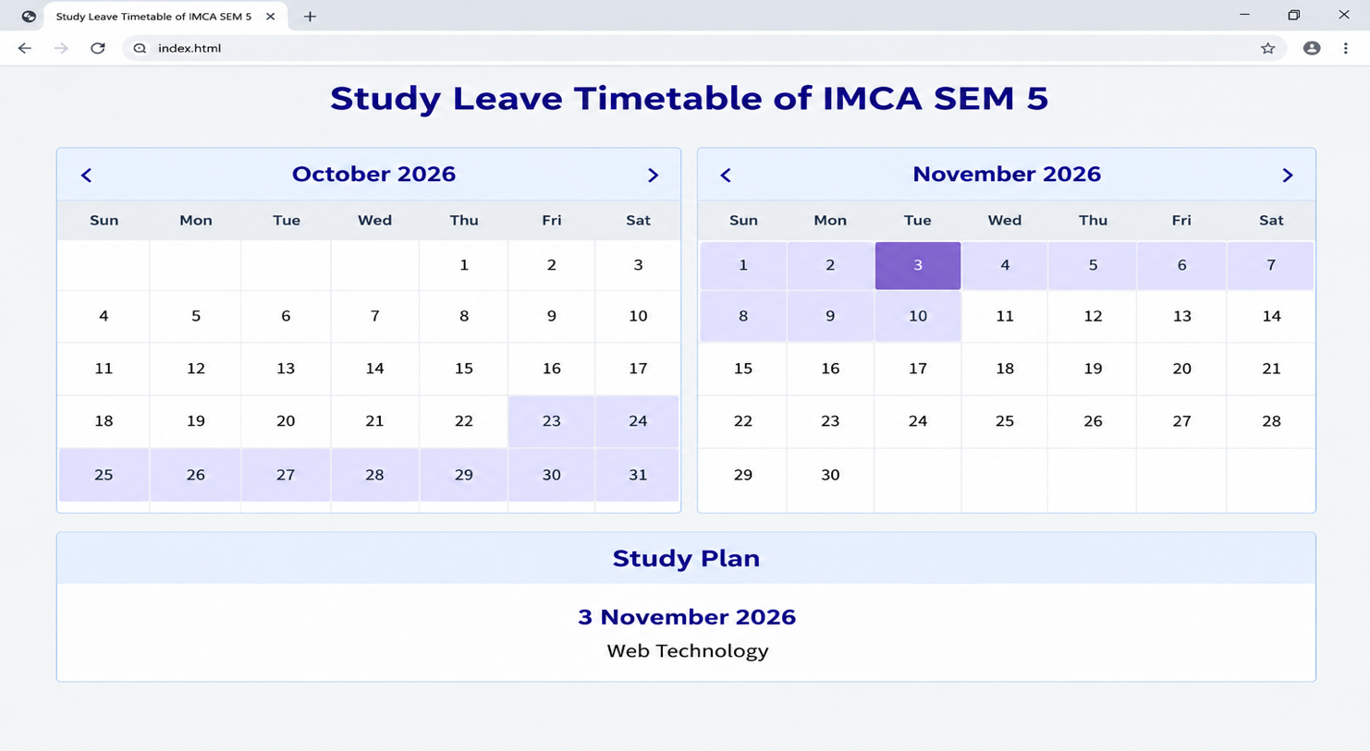
OUTPUT:

